**Lab 1 – Basics/Selectors**

**Lab 1-1**

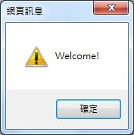Write a jQuery program to show the message: “Click on this Welcome Message!” on the browser. When the message is clicked, the dialogue box in the right is displayed.

Rewrite your program, but instead, the jQuery codes are put inside another file called welcome.js.

**Lab 1-2**

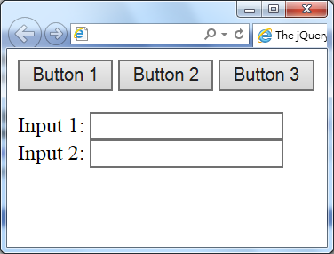Write a jQuery program to show the layout as shown, together with the following effects:

**Button 1**: When clicked, a Welcome message is displayed.

**Button 2**: When double clicked, a Good-bye message is

displayed.

**Button 3**: When the mouse enters, the button is hide;

when the mouse leaves, the button is shown.

**Input 1&2**: When it is in focus, background-color is changed to

green; when it is out of focus, background-color is

changed to red.

Given the <body> :

<button id="button1">Button 1</button>

<button id="button2">Button 2</button>

<button id="button3">Button 3</button>

<p>

Input 1: <input />

Input 2: <input />

</p>

**Lab 1-3**

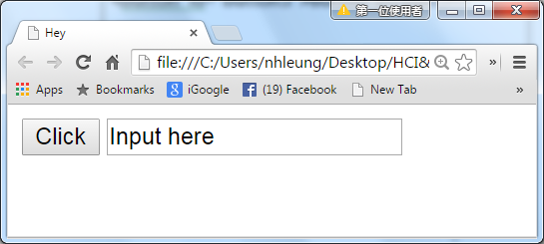

Write a jQuery program to do the followings:

1. When the button is clicked, the background color is changed to red.
2. When textbox is in focus, background color is changed to green.
3. When textbox content is changed, background color is changed to red.
4. When textbox is out of focus, background color is changed to blue.

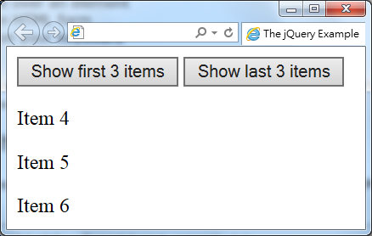**Lab 1-4**

Write a jQuery program with the layout shown.

When the left button is clicked, the first 3 items are shown.

When the right button is clicked, the last 3 items are shown.

Given the <body> :

<button id=button1>Show first 3 items</button>

<button id=button2>Show last 3 items</button>

<div>

<p>Item 1</p>

<p>Item 2</p>

<p>Item 3</p>

<p>Item 4</p>

<p>Item 5</p>

<p>Item 6</p>

</div>

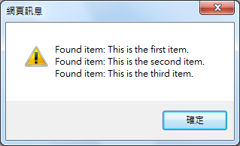**Lab 1-5**

Write a jQuery program to display the message box shown in the right when it is run.

[Hints: Use '\n' for line feed.]

Given the <body> :

<ol>

<li>This is the first item.</li>

<li>This is the second item.</li>

<li>This is the third item.</li>

</ol>

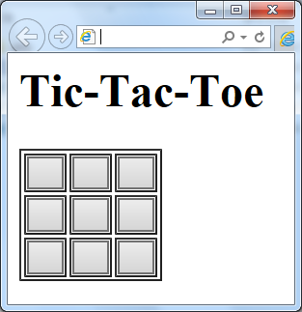**Lab 1-6**

Write a program to show the Tic-Tac-Toe in table

format as shown in the figure. Each cell of the table

contains a button.

When a button is clicked, the background color

is changed to red.

When a button is double clicked, the background

color is changed to blue.